1.
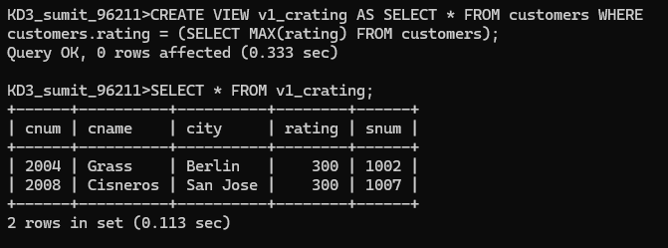
2.
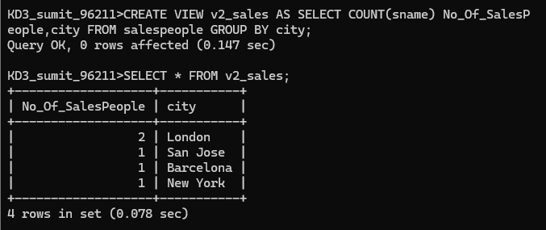
3.
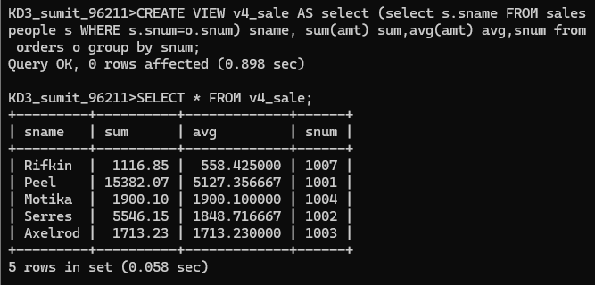

4.
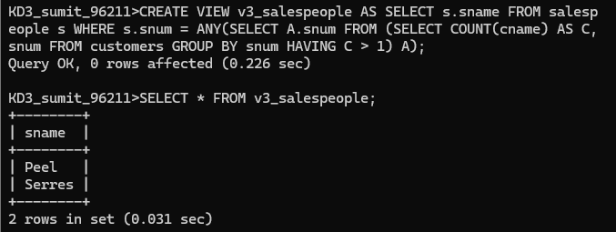
5.
Which of these views are updateable (will allow DML operations)?
#1 Create View Dailyorders as Select Distinct cnum, snum, onum, odate from Orders;
NO
#2 Create View Custotals as Select cname, Sum (amt) Sum_Amt from Orders, Customers where Orders.cnum=Customers.cnum Group by cname;
NO
#3 Create view Thirdorders as Select * from Dailyorders where odate=’1990-10-03’;
NO
#4 Create view Nullcities as Select snum, sname, city from Salespeople where city is NULL OR sname BETWEEN ‘A’ and ‘MZ’;
YES

6.
